## Screenshots of the webpage: LearnBaking

* **Main Page : Index.html page**

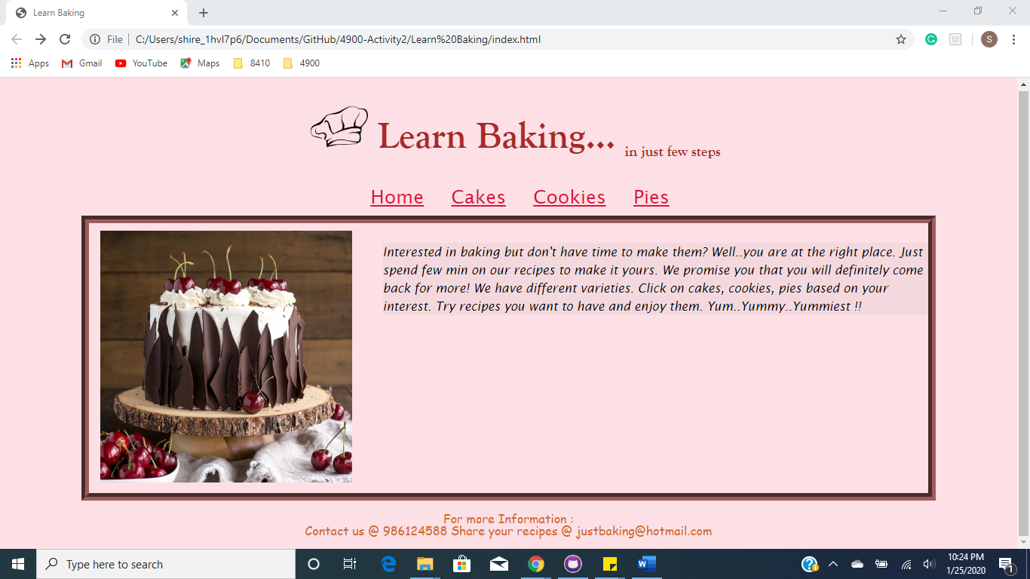

* **Cakes.html page**

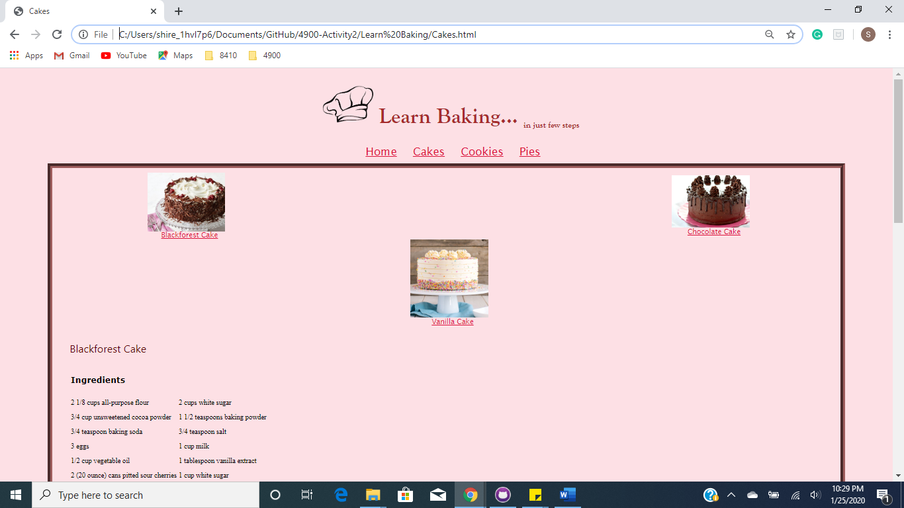

* **Cookies.html page**

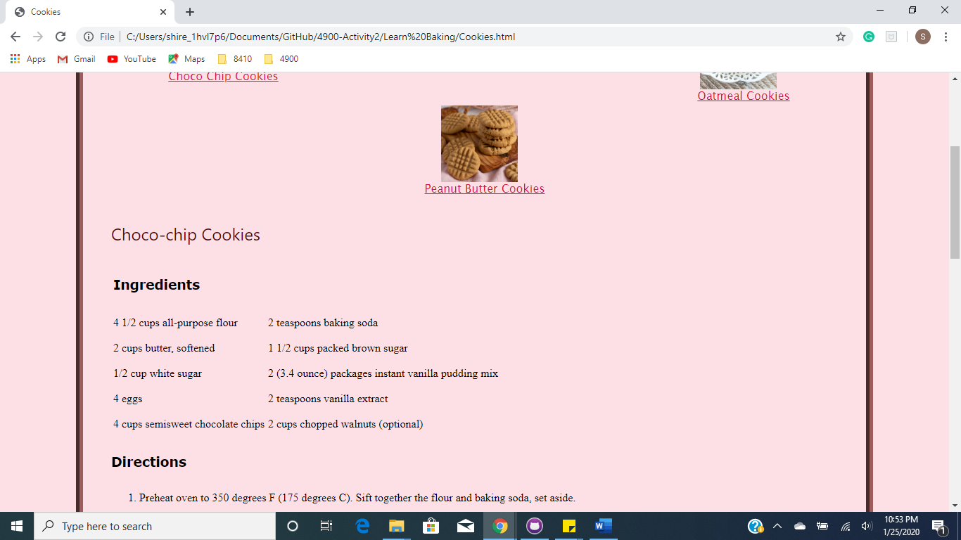

* **Pies.html page**

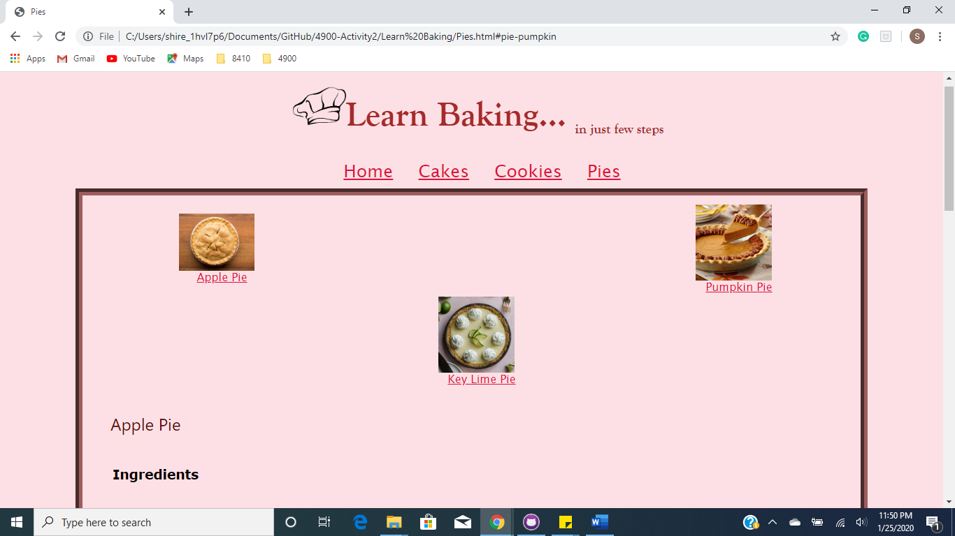

## Questions:

**a. What is the value of having a CSS file for each html page? Why not simply embed the CSS in each web page?**

**Answer:**

Having an external CSS helps in providing more simple and efficient way of designing the web pages. Providing the different properties of styles in a single CSS file gives ease to apply the same style on different pages of HTML. Although the Internal stylesheets are good, using them when there is the same design to different webpages, is cumbersome. So, a separate CSS file helps in eliminating redundancy of applying the same styles.

For example, consider the webpage I made “index.html” which has 4 links namely, index.html, cakes.html, cookies.html, Pies.html. All these links follow the same header and footer structure. So, providing the styles of header and footer in a separate CSS file “main.css” helps in eliminating redundancy in each html page.

**b. There are many cloud-based shared documents tools such as Drobox, Box, Microsoft OneDrive and GoogleDrive. What is an advantage of using a tool like Git (GitHub Desktop) and GitHub over simply using other cloud-based shared document tools to manage code?**

**Answer:**

GitHub is generally an open-source repository hub. It mainly focusses on source code management and version control whereas tools like DropBox, Google Drive mainly focus on file storage. GitHub helps in not only sharing repositories but also helps in publishing a webpage for free. Also, GitHub makes things easy. Once we create a repository and we just put our folder, it pulls and pushes requests in a fraction of seconds on our commands. It also helps in professionally sharing our work and notifies any changes being done by other users who are currently working on the same document. In such a situation, GitHub compares the code, tracks it between the two users, checks for unmatched lines of code and notifies the user who is committing it.

## Published Website on GitHub Pages

<https://shireen3108.github.io/>

## Credits and Citation Links:

Images and recipes are referenced from

**Main page Cake image:**

<https://livforcake.com/black-forest-cake/>

**Chef cap :**

<https://www.pinclipart.com/pindetail/wmbRo_chef-hat-transparent-png-chef-hat-vector-png/>

**Peanut butter cookie**:

Recipe: <https://www.allrecipes.com/recipe/10275/classic-peanut-butter-cookies/print/?recipeType=Recipe&servings=24&isMetric=false>

Image:<https://preppykitchen.com/wp-content/uploads/2019/06/Peanut-Butter-Cookie-Recipe2-or-blog.jpg>

**Choco Chip cookie:**

Recipe: <https://www.allrecipes.com/recipe/15004/award-winning-soft-chocolate-chip-cookies/print/?recipeType=Recipe&servings=72&isMetric=false>

Image:<https://www.handletheheat.com/wp-content/uploads/2018/02/BAKERY-STYLE-CHOCOLATE-CHIP-COOKIES-9.jpg>

**Oatmeal Cookie:**

Recipe: <https://www.allrecipes.com/recipe/24445/chewy-chocolate-chip-oatmeal-cookies/print/?recipeType=Recipe&servings=42&isMetric=false>

Image: <https://i2.wp.com/www.livewellbakeoften.com/wp-content/uploads/2017/01/Soft-and-Chewy-Oatmeal-Raisin-Cookies-3.jpg?resize=1360%2C2040&ssl=1>

**Chocolate Cake:**

Recipe : <https://www.allrecipes.com/recipe/7565/too-much-chocolate-cake/print/?recipeType=Recipe&servings=12&isMetric=false>

Image: http://makesbakesanddecor.com/wp-content/uploads/2017/10/006-5.jpg

**Black forest Cake:**

Recipe : <https://www.allrecipes.com/recipe/8095/black-forest-cake-i/print/?recipeType=Recipe&servings=12&isMetric=false>

Image:

<https://food.fnr.sndimg.com/content/dam/images/food/fullset/2018/2/7/0/FNM_030118-Black-Forest-Cake-Recipe_s4x3.jpg.rend.hgtvcom.616.462.suffix/1518020394494.jpeg>

**Vanilla cake :**

Recipe: <https://www.allrecipes.com/recipe/231616/vegan-basic-vanilla-cake/print/?recipeType=Recipe&servings=8&isMetric=false>

<https://livforcake.com/wp-content/uploads/2017/06/vanilla-cake-thumb.jpg>

**Apple Pie :**

Recipe: <https://www.allrecipes.com/recipe/12682/apple-pie-by-grandma-ople/print/?recipeType=Recipe&servings=8&isMetric=false>

Image : https://food.fnr.sndimg.com/content/dam/images/food/fullset/2013/6/28/0/FNK_Apple-Pie_s4x3.jpg.rend.hgtvcom.826.620.suffix/1382545039107.jpeg

**Pumpkin Pie:**

Recipe: <https://www.allrecipes.com/recipe/23439/perfect-pumpkin-pie/print/?recipeType=Recipe&servings=8&isMetric=false>

Image :

<https://www.landolakes.com/RecipeManagementSystem/media/Recipe-Media-Files/Recipes/Retail/x17/19055-maple-pecan-pumpkin-pie-600x600.jpg?ext=.jpg>

**Key lime Pie :**

Recipe: <https://www.allrecipes.com/recipe/15880/key-lime-pie-vii/print/?recipeType=Recipe&servings=8&isMetric=false>

Image: <https://www.browneyedbaker.com/wp-content/uploads/2012/05/key-lime-pie-2-1200.jpg>